**Reverse proxy:**

* For example, if a client request something from the browser, the nginx will receive the request, get the data from php and give it to client. It works like reverse proxy.

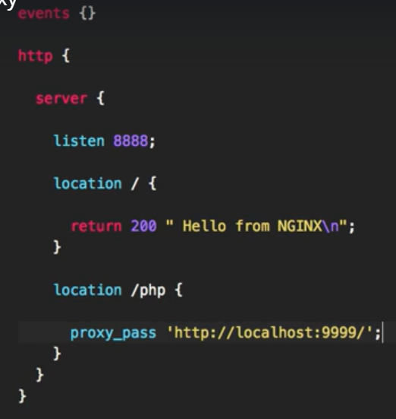

* We need to add the php server details as **“proxy_pass”** and the location of context in config file as above.
* Save the file and reload the configuration.

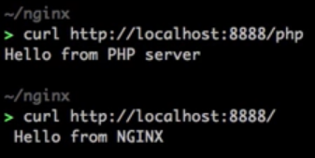

* We can see now above that when we hit with **/php**, we are getting the response from php otherwise we are getting from nginx only.

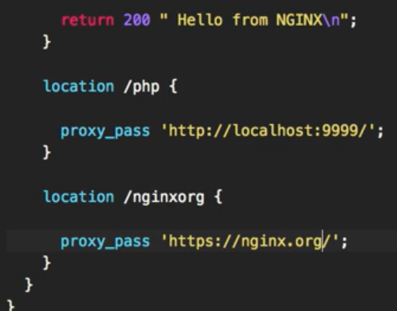

* We can also add the remote site as proxy_pass as above we added **“nginx.org”**
* Now, when we do curl, we get some html content response as below.

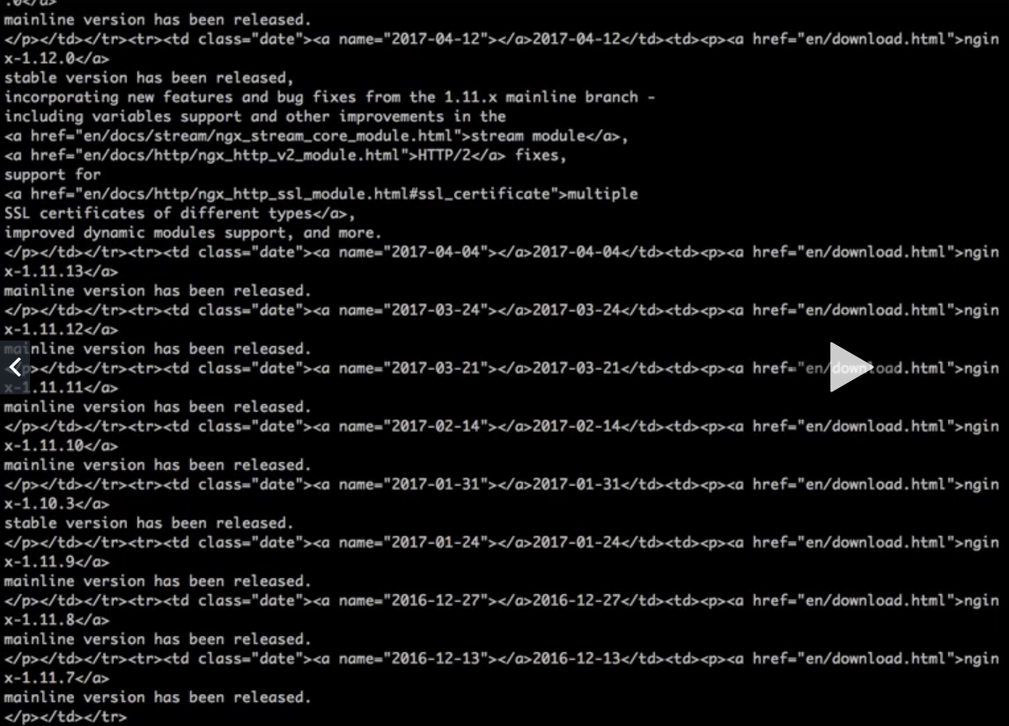

* Even if we use the same URL in browser, it will load as if the complete website is proxied by our server.

